COMSATS University Islamabad, Islamabad Campus



Secure Software Design and Development
Lab Final

DAST (OWASP ZAP)

Student Names | Muhammad Awais , Muhammad Umair Nazir , Muhammad Umar
Registration Numbers | SP23-BCT-008 , SP23-BCT-038 , SP23-BCT-040
Submission Date | 12 June 2026
Submitted To | Mr Muhammad Ahmed Nawaz

Step 1- Owasp Zap was already installed
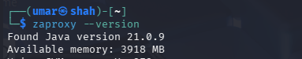
Step 2- Start all services
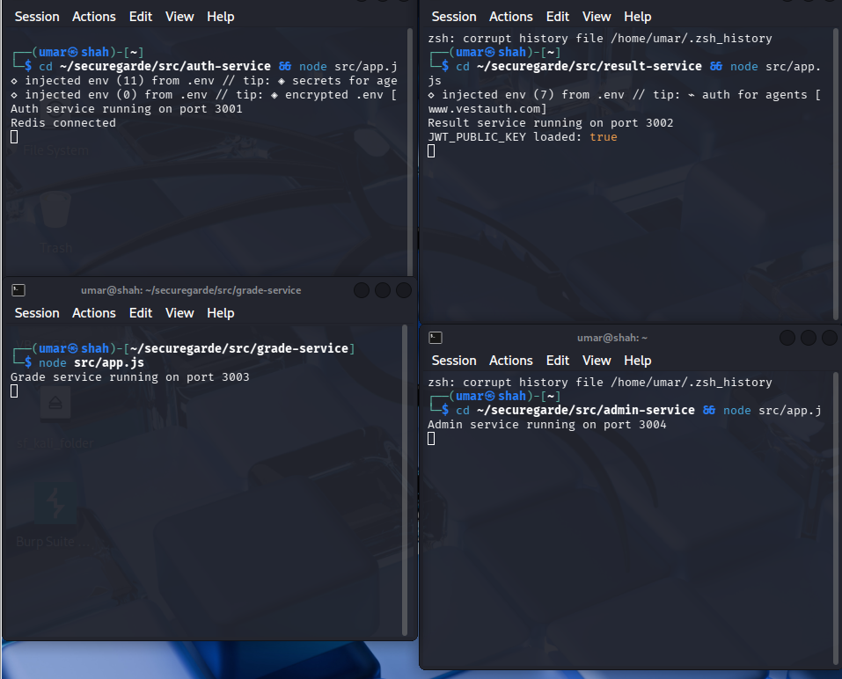

Step 3- Scan Auth Service at port 3001
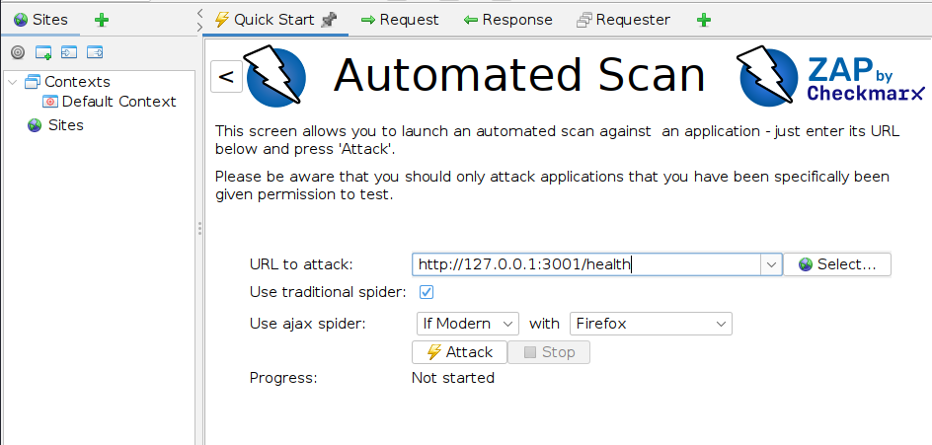

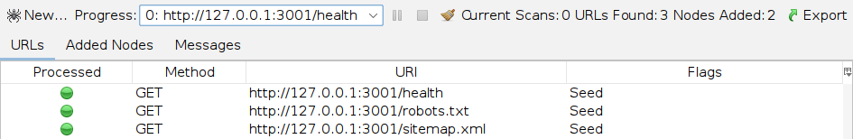

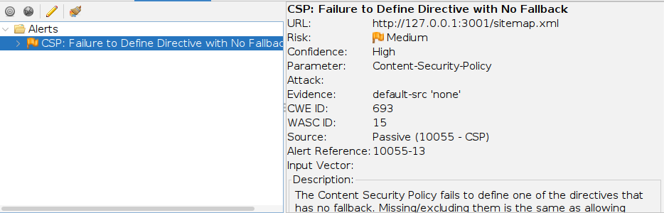

Step 4- Scan Result Service at port 3002
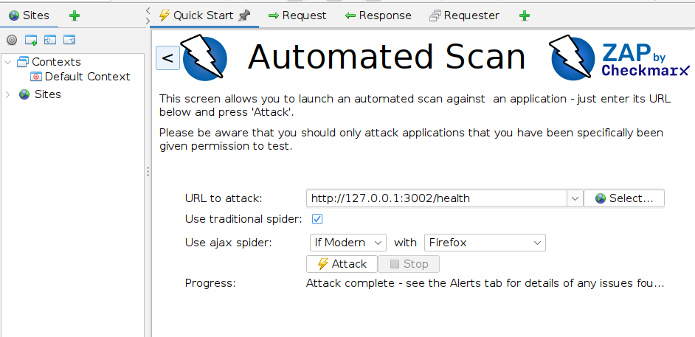

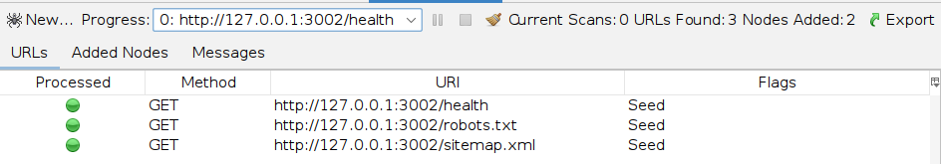

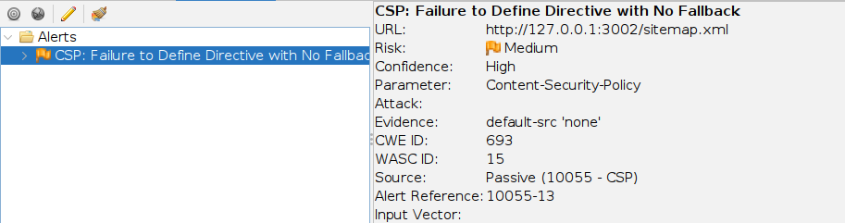

Step 5- Scan Grade Service at port 3003
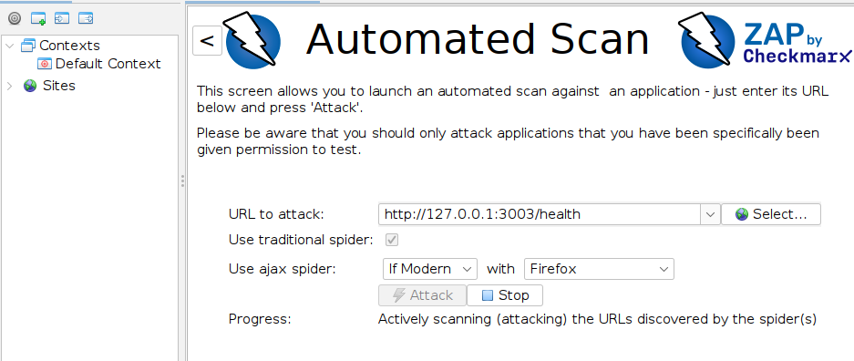

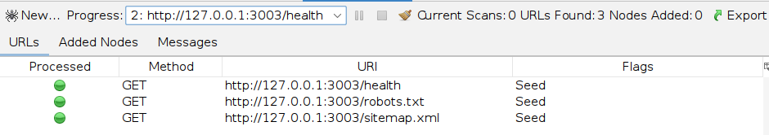

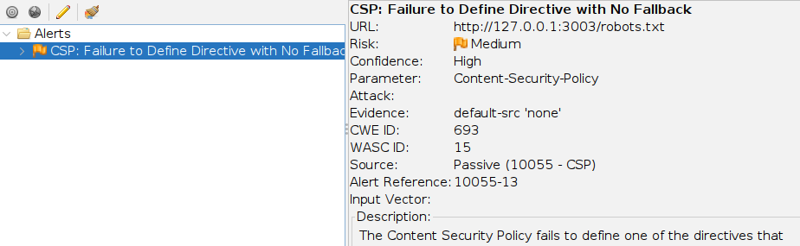

Step 6- Scan Admin Service at port 3004
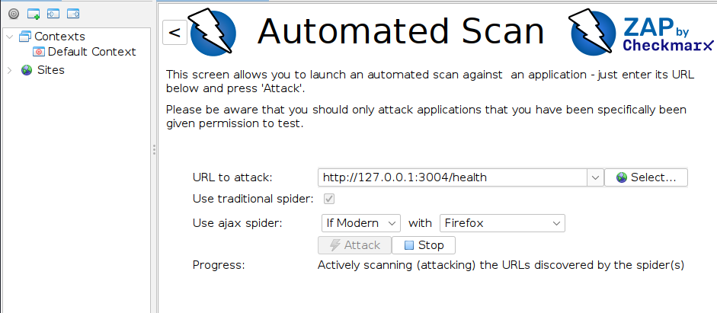

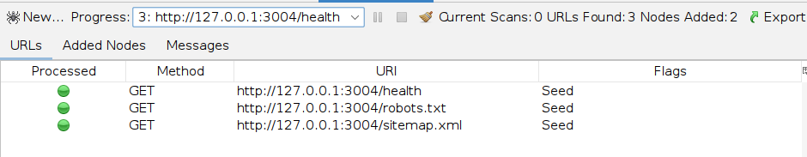

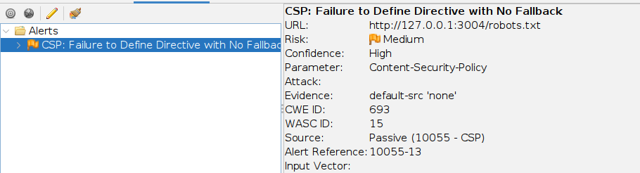

Step 7- Mitigation for generated alerts for each service
Auth service
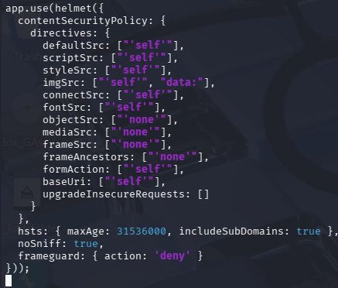
Result service
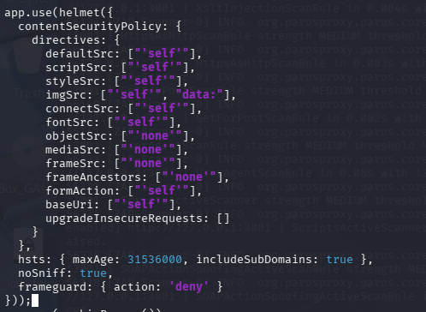
Grade service
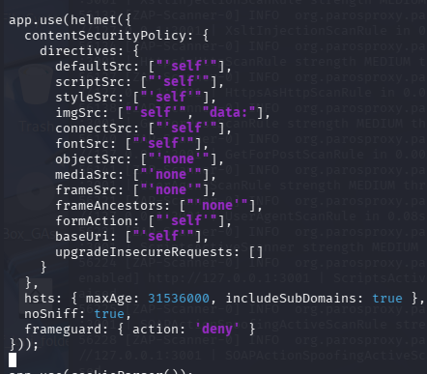
Admin service
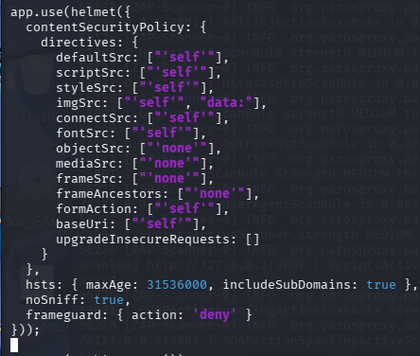

Finding: CSP Failure to Define Directive with No Fallback
Tool: OWASP ZAP (Passive Scan)
Risk: Medium
CWE: CWE-693
Description: The Content Security Policy was missing explicit fallback directives allowing potential XSS and resource injection attacks.
Remediation: Added explicit directives for objectSrc, mediaSrc, frameSrc, formAction, baseUri and upgradeInsecureRequests to helmet CSP configuration.
Status: Fixed and verified

 | Before Fix | After Fix
Auth Service | 1 alert (CSP Medium) | 0 alerts
Result Service | 1 alert (CSP Medium) | 0 alerts
Grade Service | 1 alert (CSP Medium) | 0 alerts
Admin Service | 1 alert (CSP Medium) | 0 alerts

